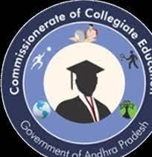
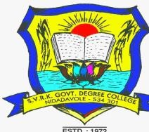
SRI VELAGAPUDI RAMAKRISHNA
GOVERNMENT DEGREE COLLEGE
NIDADAVOLE, E. G. DIST, A. P.

Principal : Dr. K. Jyothi
Vice Principal : Sri. E. Nageswara Rao
News Letter Co Ordinator : Dr. V.V.Ravindra

1. A.P. FORMATION DAY.
2. BLOOD DONATION CAMP BY NSS.
3. SIP.
4. EXTENTION LECTURE BY DEPT. OF ENGLISH.
5. NAAC RECORDS VERIFICATION.
6. INTERNSHIP VISIT BY PRINCIPAL.
7. NATIONAL CONSTITUTION DAY BY DEPARTMENT OF POLITICAL SCIENCE.
8. DISTRIBUTION OF FREE BUS PASS TO POOR STUDENTS.
9. VALEDICTORY FUNCTION TO SIP STUDENTS.
10. PRESS CLIPS.

Sri Velagapudi Ramakrishna Govt. Degree College for Men was established in the year 1971 at Nidadavole.
The College is affiliated to the Adikavi Nannaya University, Rajamahendravaram. The Lions club as well as the people of Nidadavole town donated funds liberally for its establishment.
Dr. B.V.L.N. Raju, the founder president of the college committee and Sri Venkata Ratnam, the founder secretary of the college committee strived hard for the sanction of the college
As a result of their hard work and persuasion the college was sanctioned vide G.O.M.S. No 147 Edn Dated 16-09-1971.
At the beginning B.A. and B.Com courses were sanctioned in the year 1971 and subsequently B.Sc, courses (MPC &CBZ) were sanctioned in the year 2004.
B.Com. (Computers) and B.Sc. (MPCs) courses were sanctioned in the year 2020.

B.Com (Computers) and B.Sc. (MPCs) courses were sanctioned in the year 2020.

B.Com (Computers) and B.Sc. (MPCs) courses were sanctioned in the year 2020.

Accredited with NAAC by ‘’B’’ Grade
An ISO 9001 : 2005 Certified College

AFFILIATED TO ADIKAVI NANNAYYA UNIVERSITY

A P STATE FORMATION DAY
COORDINATOR : Dr. B. SOWJANYA

The Department of History Conducted an Essay Writing Competition on the Occasion of Andhra Pradesh State Formation Day which is on November 1st 2022 at III BA Class Room at 2:00 PM for All BA Students. The Topic was “Role of Potti Sree Ramulu in Formation of Andhra State.” There are 16 Participants are attended to this Essay Writing Competition. After the evolution of scripts we selected Three participants. The duration for the competition is one and half hour. After finishing the Essay Writing Competition we collected all the 16 scrip’s and valuated them. We finally selected Three Students they got I, II& III Places In the afternoon session, at 3:30 PM. Book Prizes given to Winners on the hands of Our Principal Madam Dr. K Jyothi garu and Vice Principal Sri E. Nageswara Rao garu.
First place secured by D. Kiran from I BA Class
Second place secured by P. Dirsini from II BA Class
Third Place secured by G. Sarojini from II BA Class

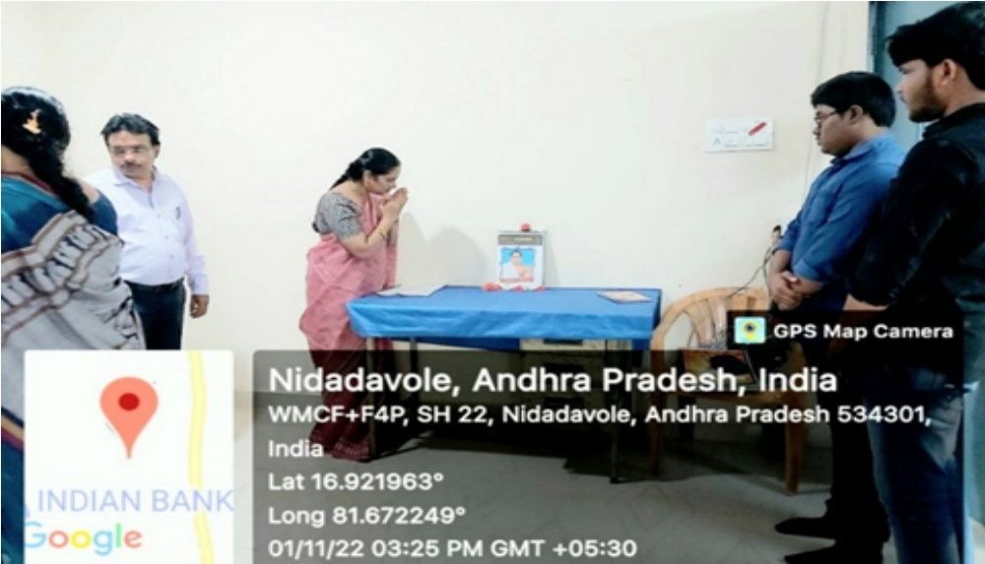

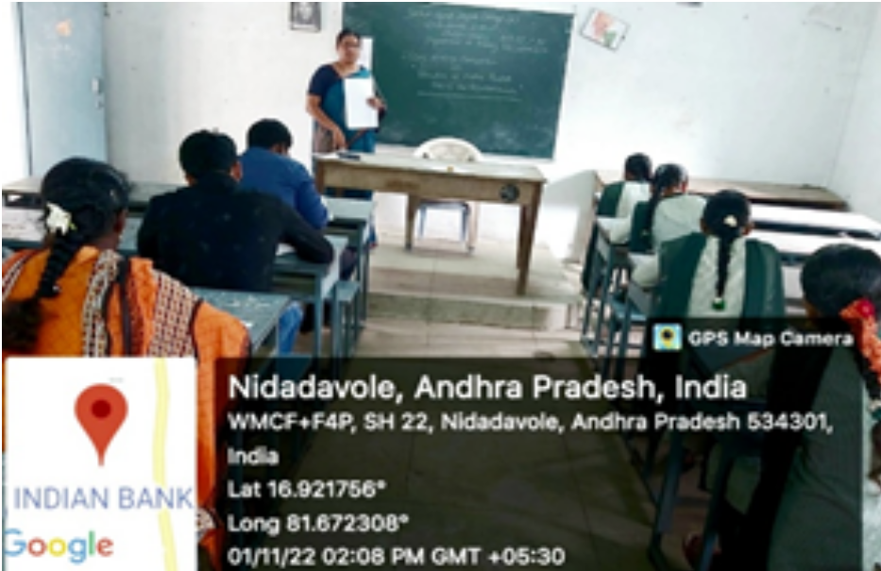

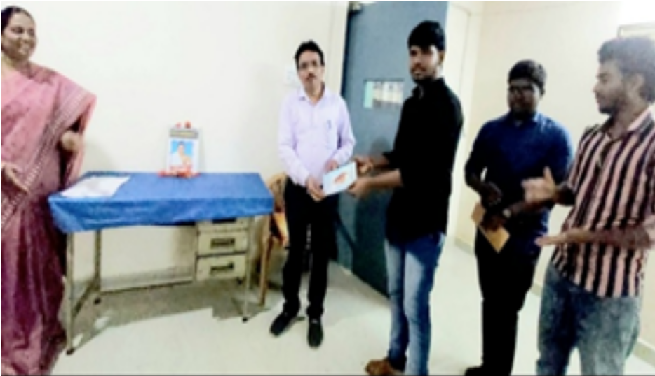

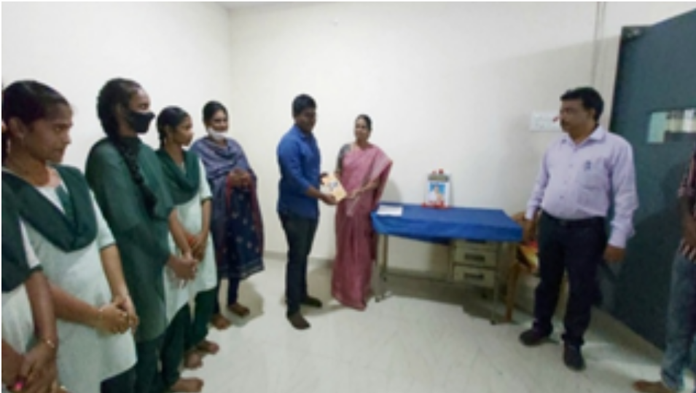

BLOOD DONATION CAMP
COORDINATOR : Dr. S. PRASADA RAO
National Service Scheme of our college in association with Rotary Club Nidadavole arranged Blood Donation Programme.
10 students were donated voluntarily their blood to the poor and needy patients.
Principal Dr. K. Jyothi and NSS PO Dr. S. Prasada Rao were present.

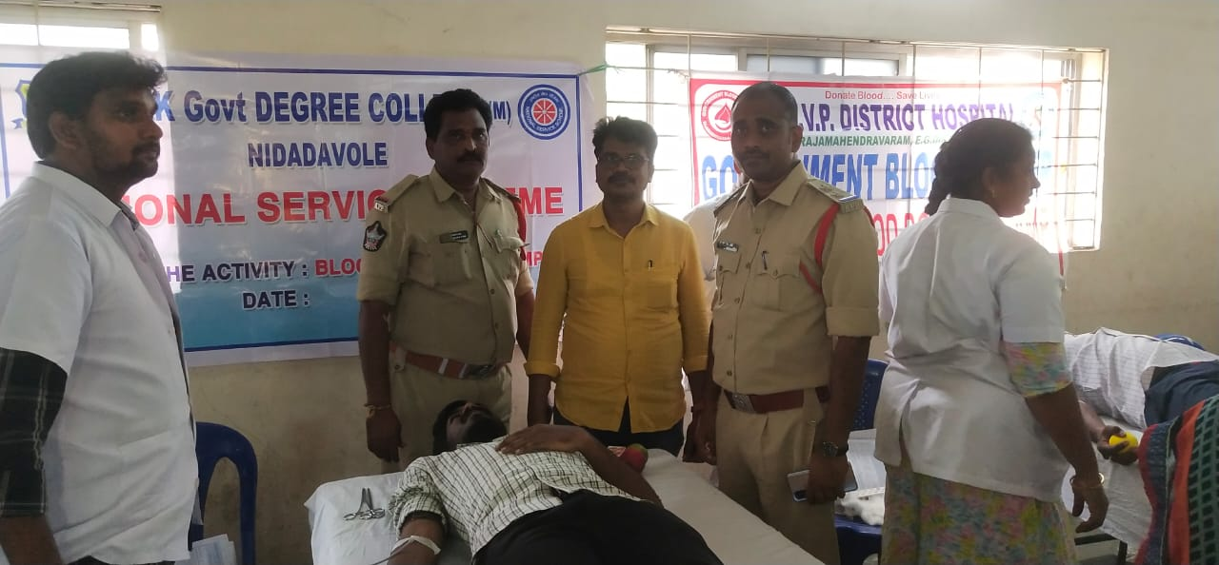

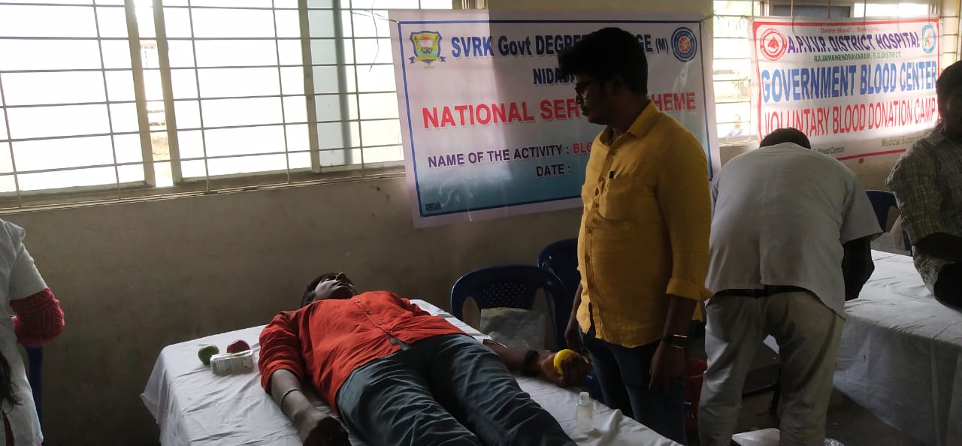

COORDINATOR : Dr. P.S.S.SRAVANTHI
Student induction programme

EXTENTION LECTURE
COORDINATOR : Dr. S. PRASADA RAO

Dr. S. Prasada rao Leturer in English delivered a guest Lecture at Government Degree College Ulavapadu Prakasam District.

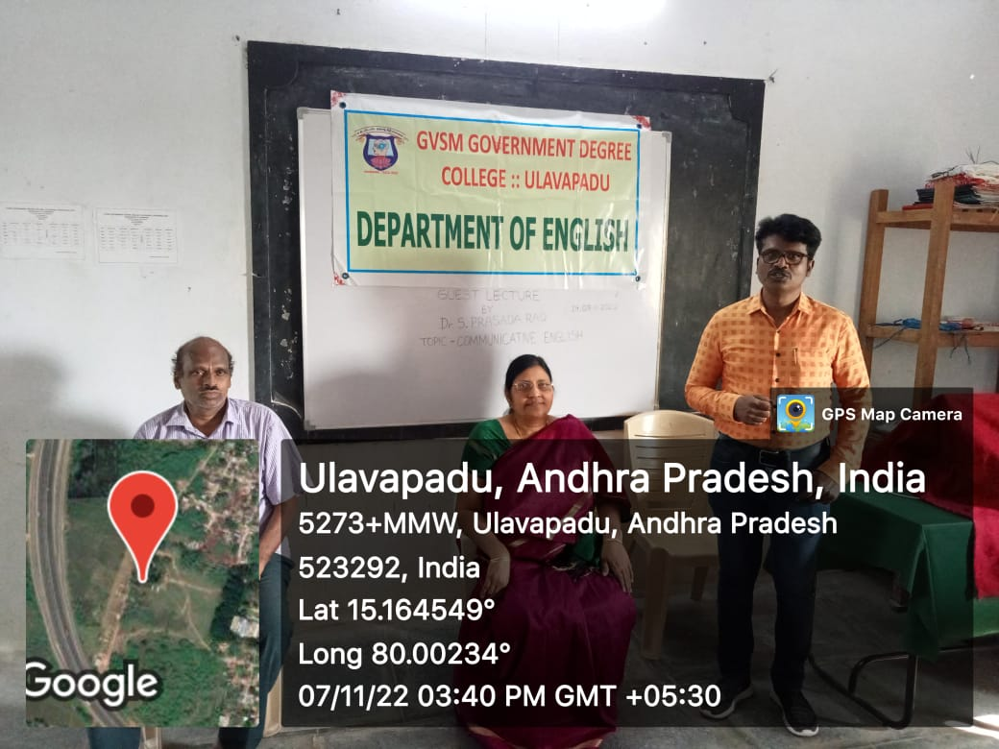

COORDINATOR : Dr.T. HANUMANTHA RAO
NAAC RECORDS VERIFICATION

In view of NAAC preparation, all the department’s academic as well as administrative records were verified by the Principal De. K. jyothi, Vice principal Sri. E. Nageswara Rao and NAAC coordinator Dr. T. Hanumantha Rao along his team.

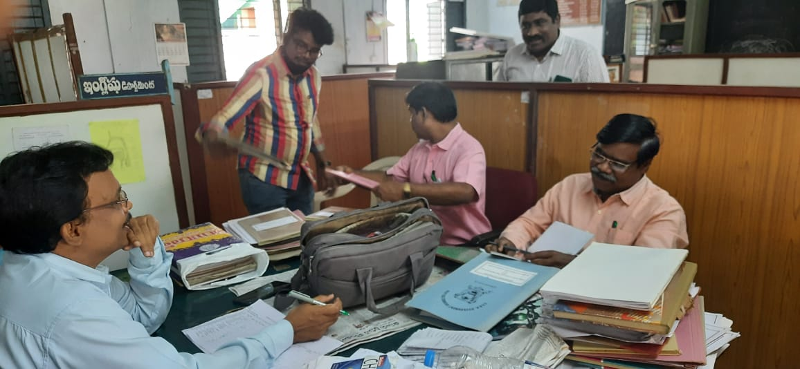

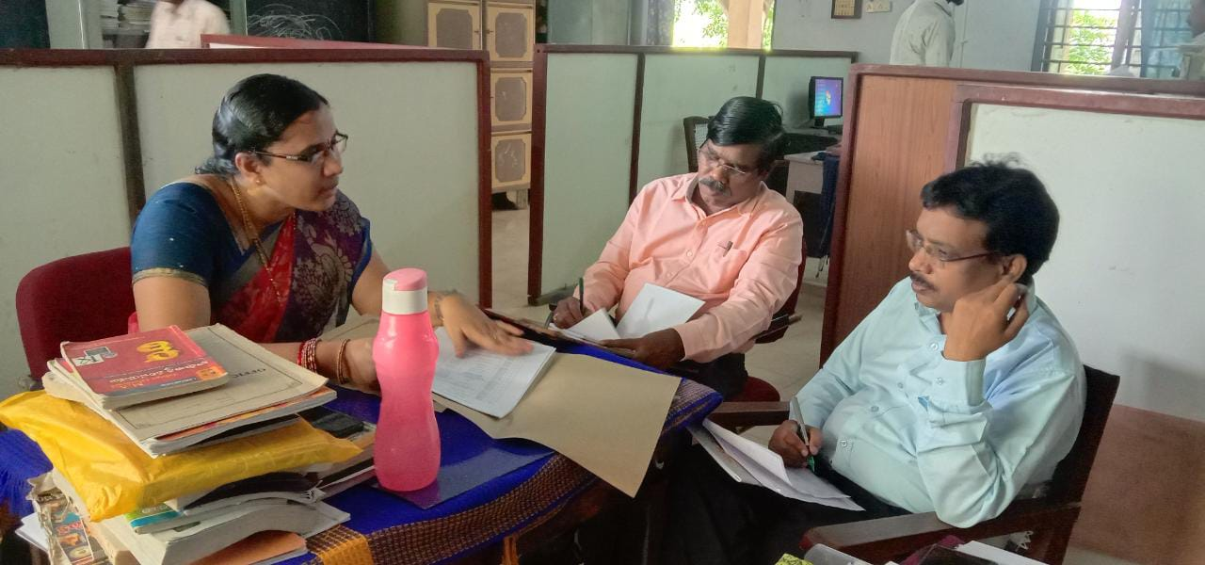

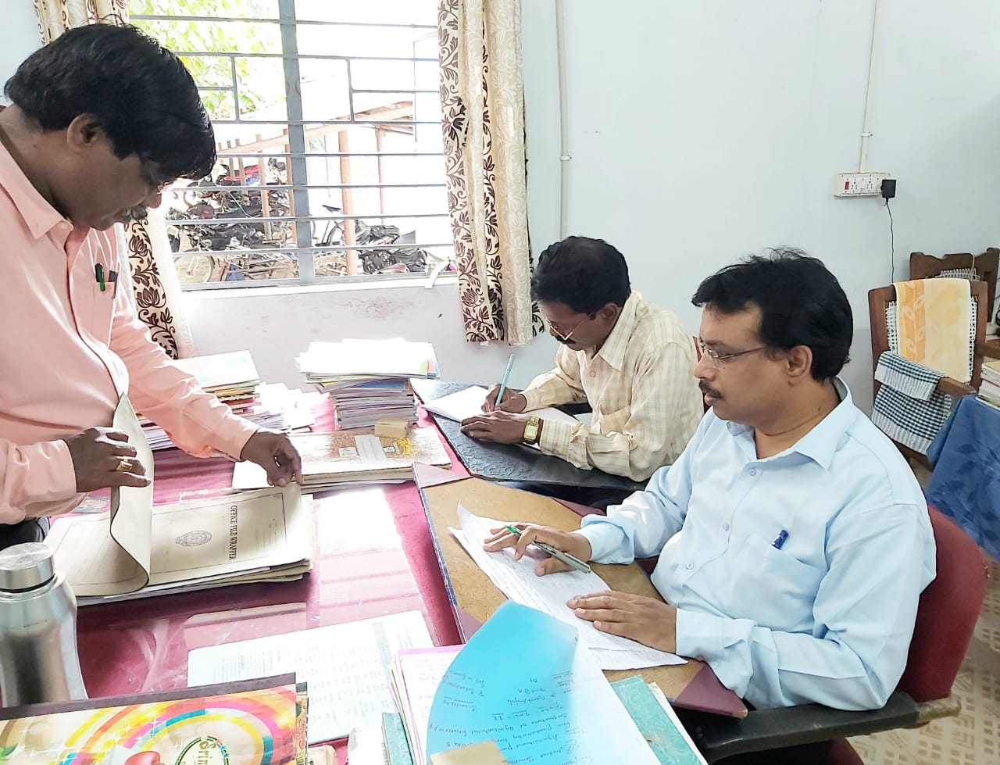

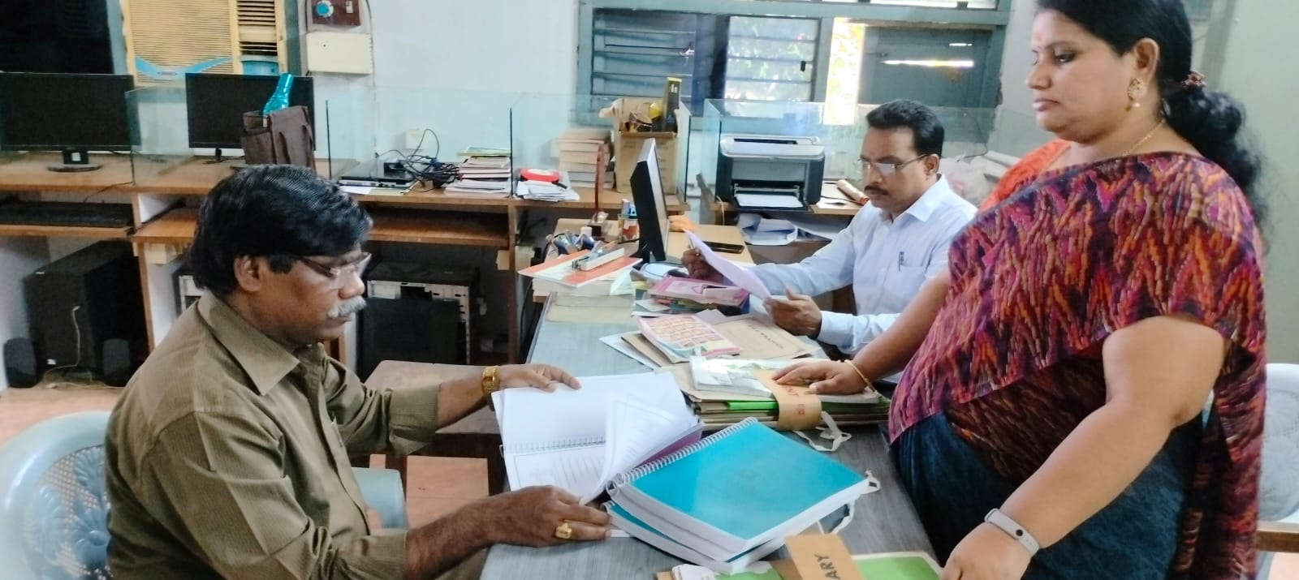

]

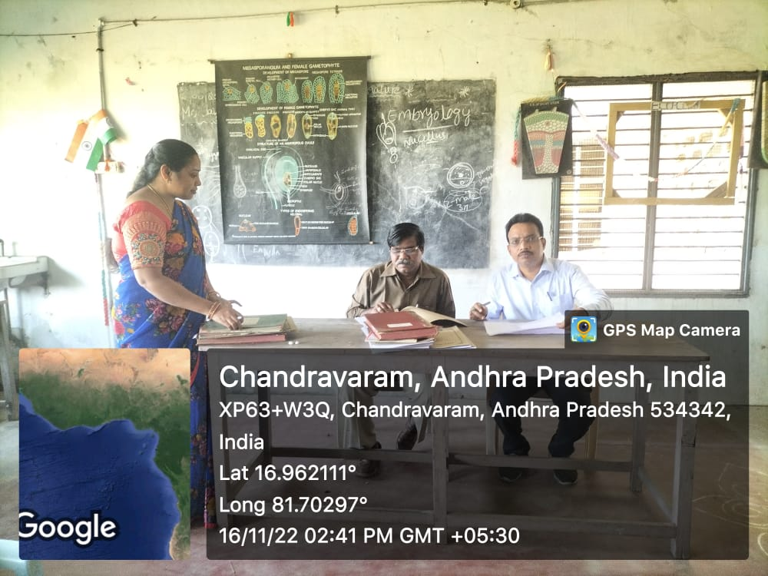

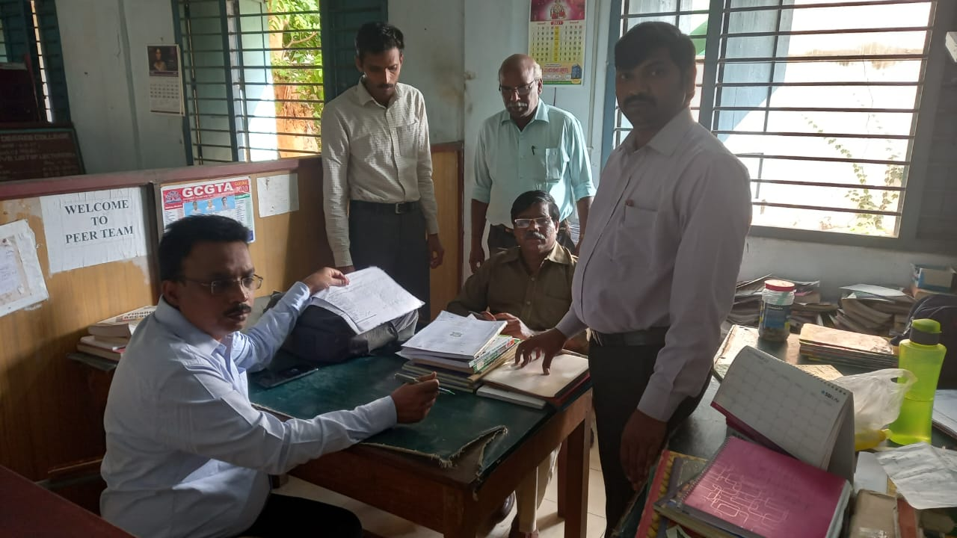

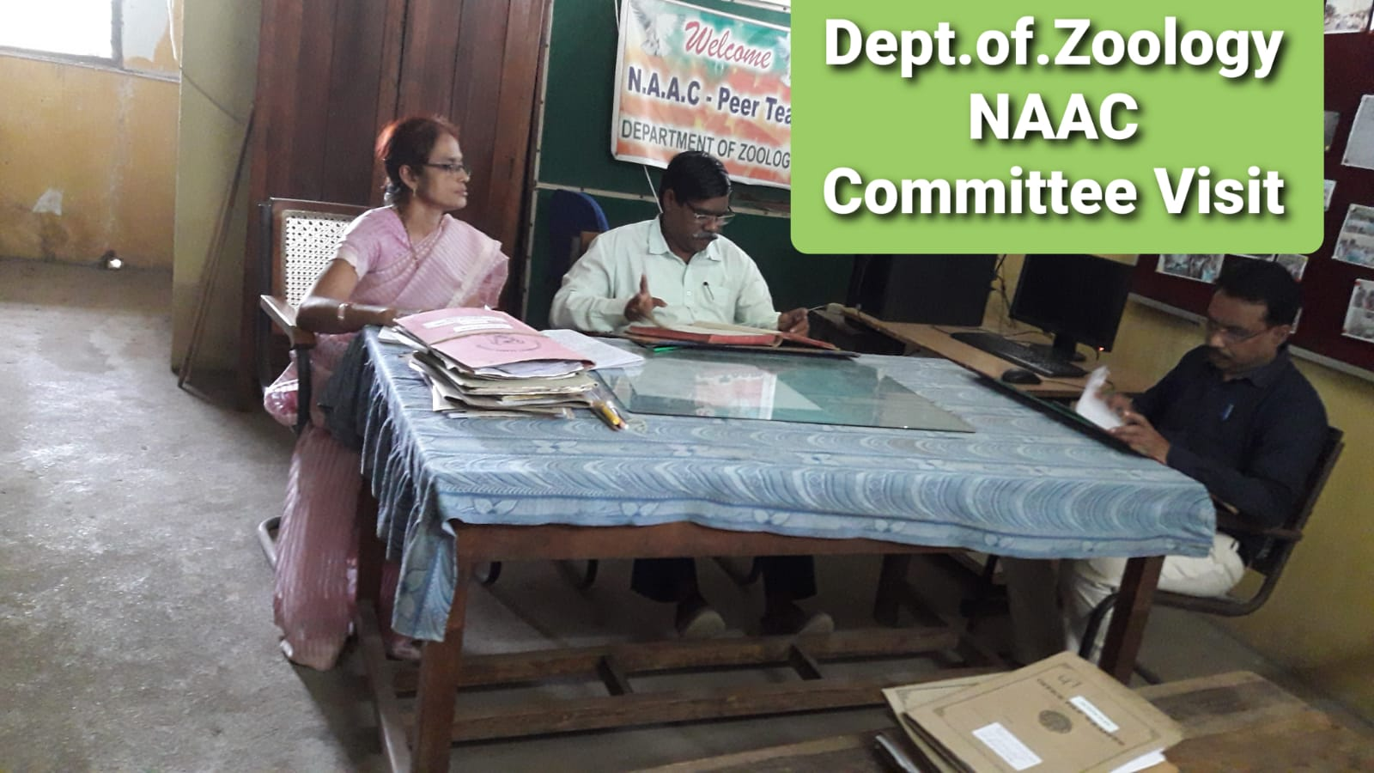

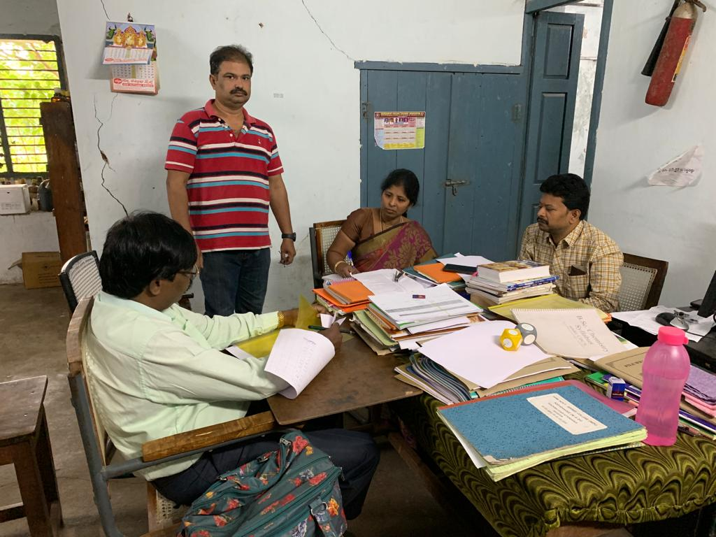

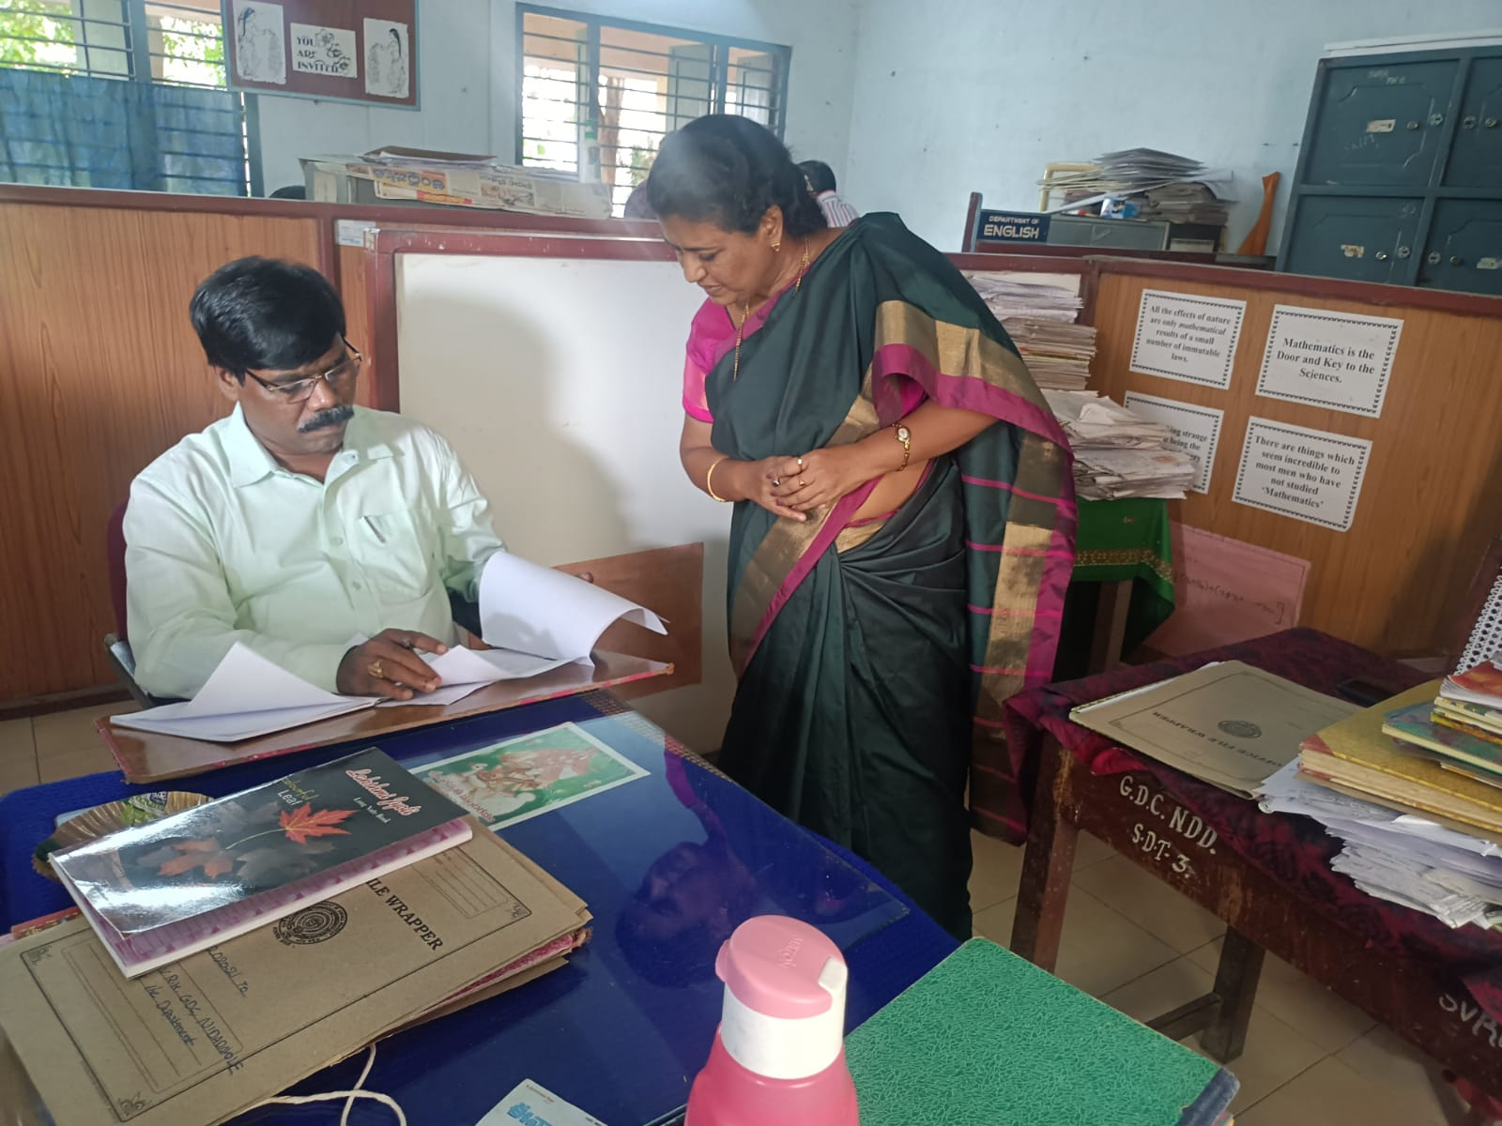

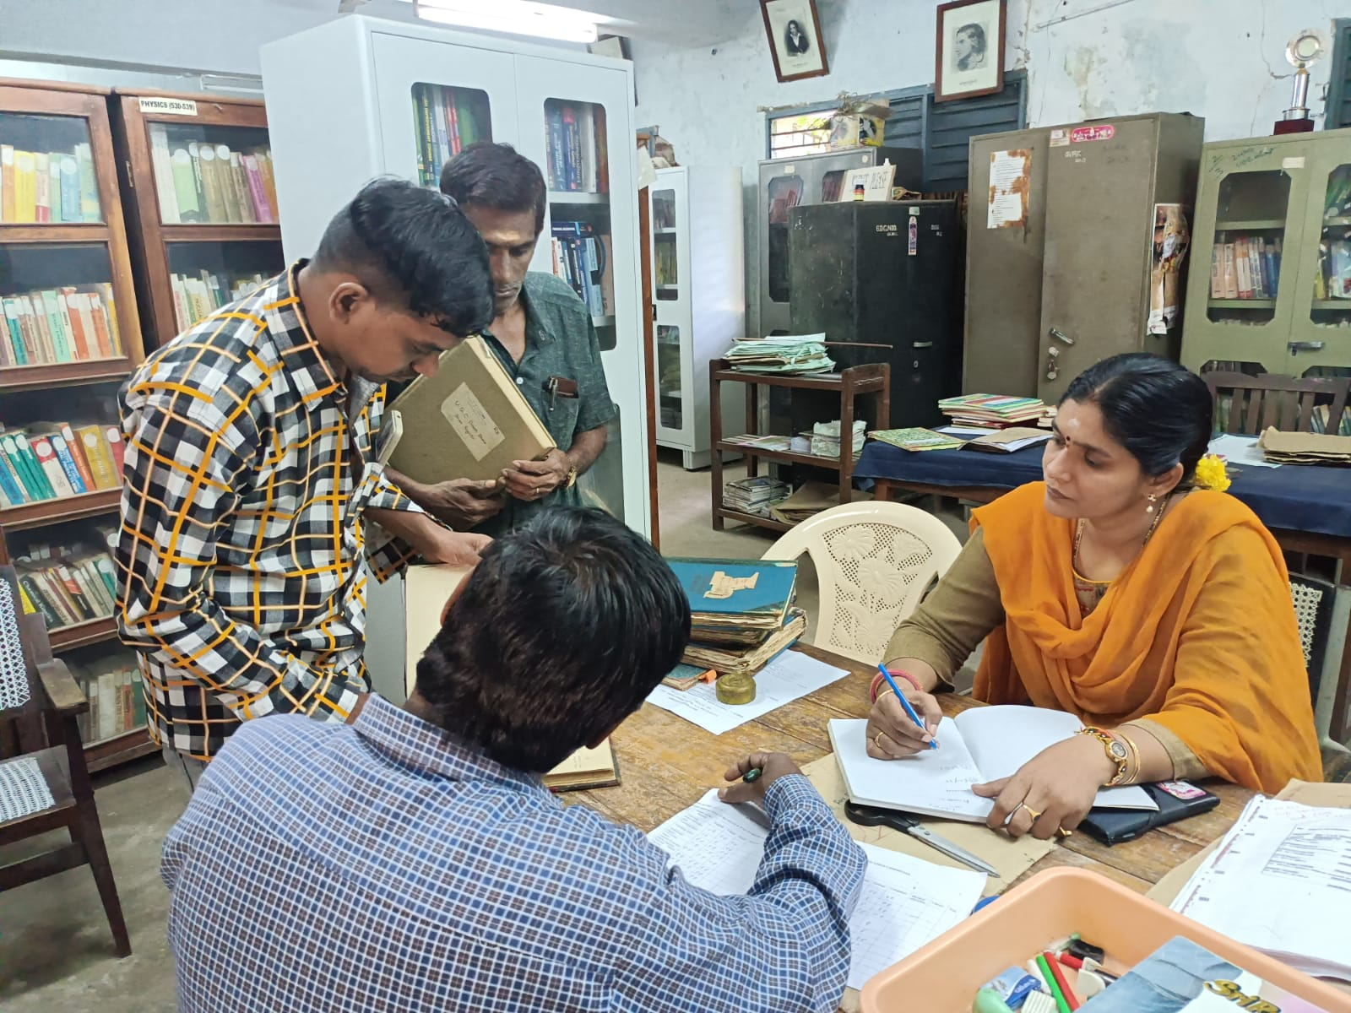

INTERNSHIP VISIT BY PRINCIPAL
Principal Dr. K. Jyothi along with Vice principal Sri. E. Nageswara Rao and IQAC Coordinator were visited various industries in connection with internship of the students. Principal checked the day today activity register of the students and daily attendance. She has given some instructions and suggestions to improvise their internship work.

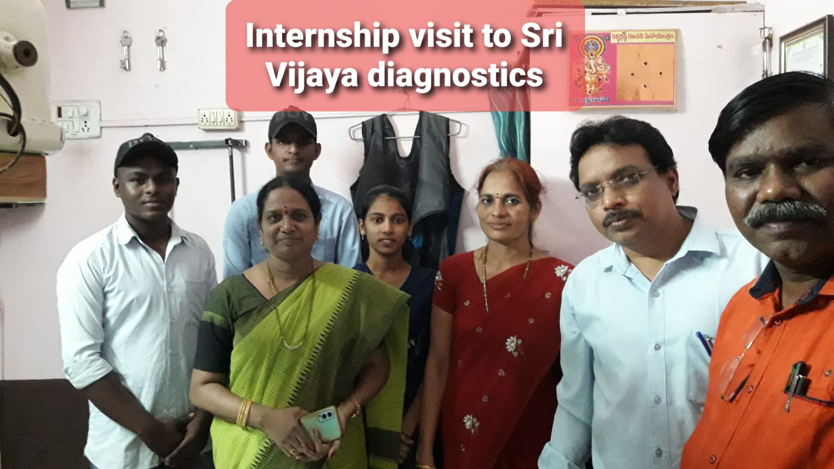

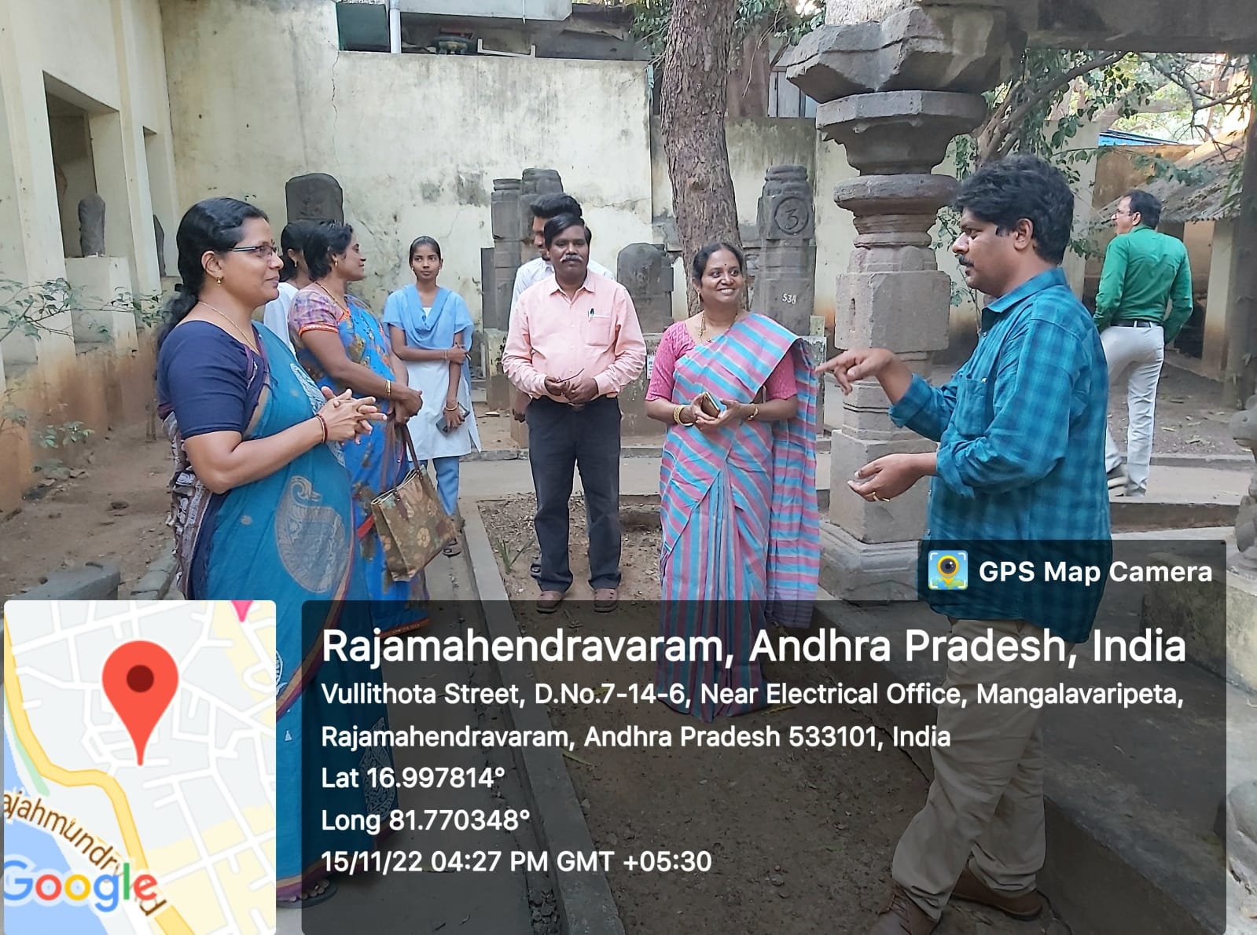

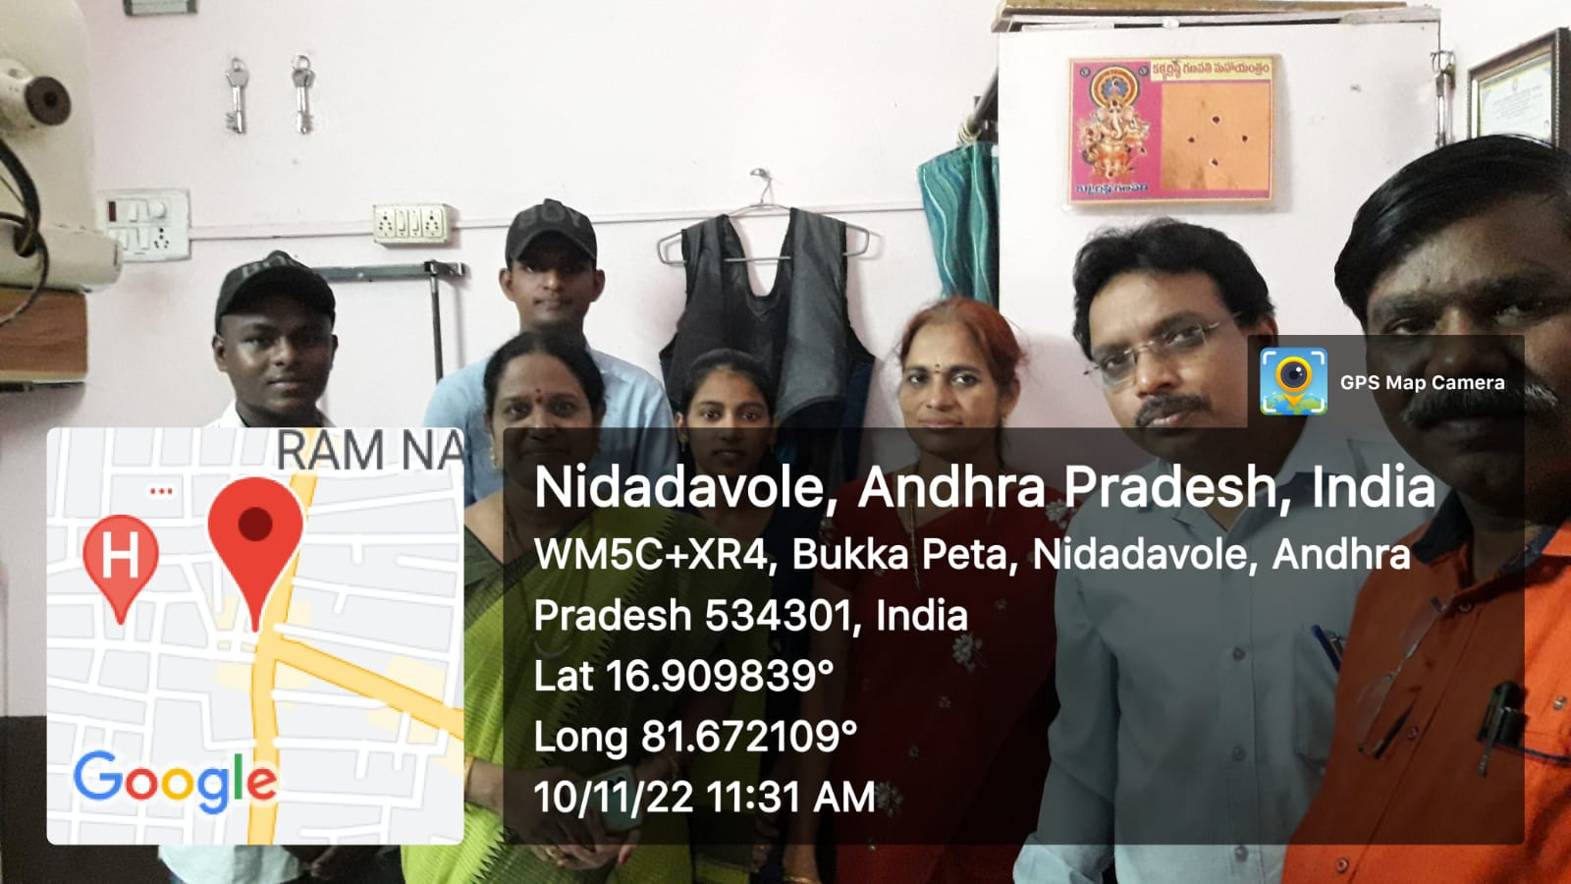
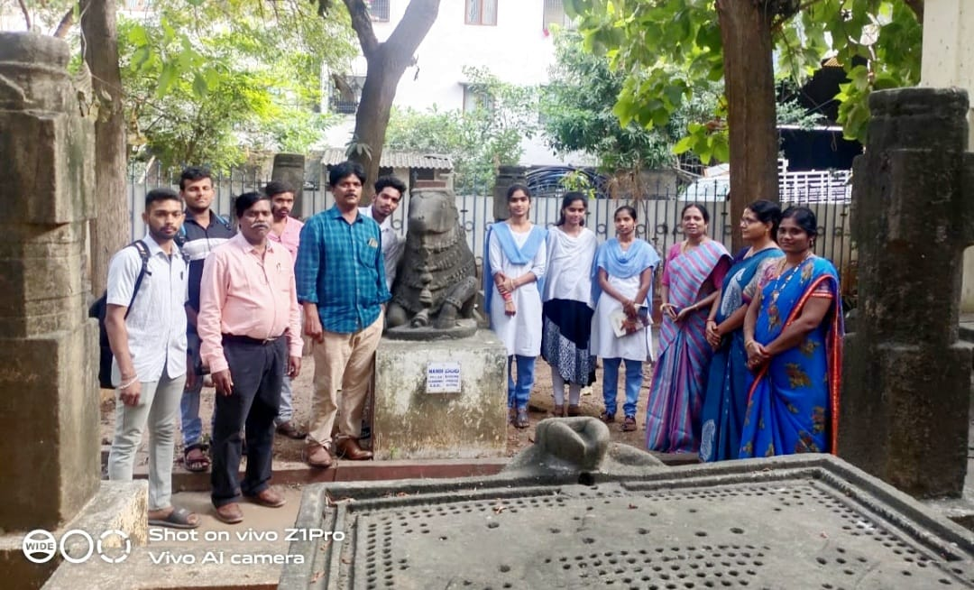
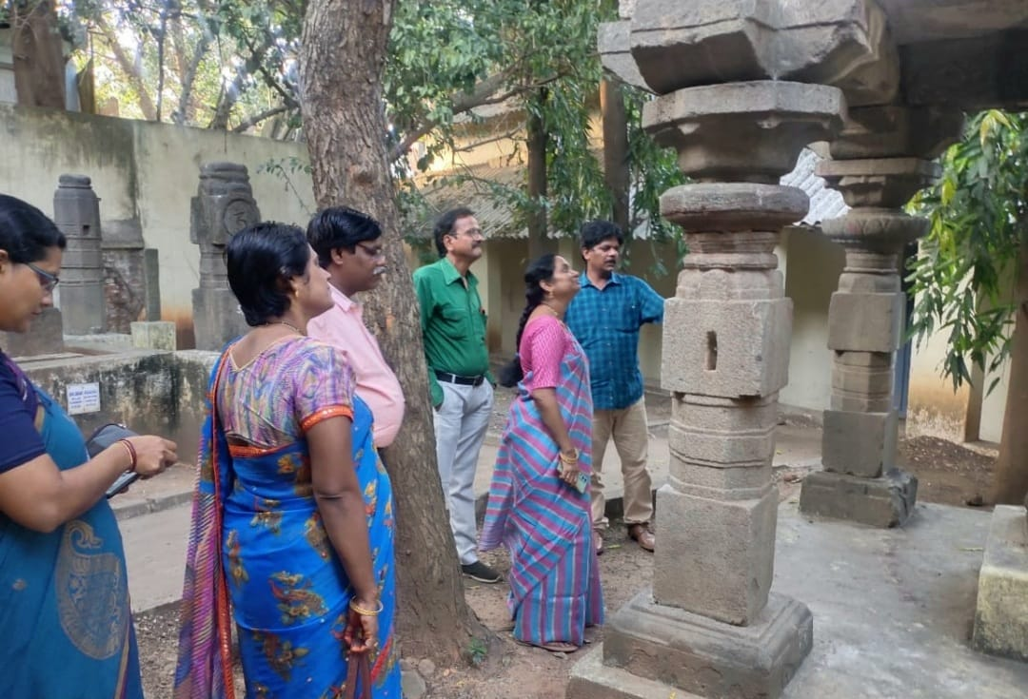
NATIONAL LIBRARY WEEK
National Library Week celebrations was held at our college Library in a grand way. The schedule of this programme is from 14th November to 20th November.

FREE BUS PASS TO POOR STUDENTS

SIP VALEDICTORY FUNCTION

PRESS CLIPS

